Length
# Source: AI Source: Provided by: [Data Path: Persons Table -> ID Column: 1, Name_En Column: Motasem Essam] -> From: [ChatGPT] on [7/17/2026]
Length is the measurement of the distance between two points or the extent of an object in one dimension. It is one of the seven base quantities in the International System of Units (SI) and is fundamental to mathematics, science, engineering, architecture, manufacturing, navigation, and everyday life.
Length is commonly used to describe how long, wide, tall, deep, or far something is.

Definition
# Source: AI Source: Provided by: [Data Path: Persons Table -> ID Column: 1, Name_En Column: Motasem Essam] -> From: [ChatGPT] on [7/17/2026]
Length is the physical quantity that measures the linear distance between two points or the size of an object along a single dimension.
The SI base unit of length is the meter (m).

Purpose
# Source: AI Source: Provided by: [Data Path: Persons Table -> ID Column: 1, Name_En Column: Motasem Essam] -> From: [ChatGPT] on [7/17/2026]
Length measurement is used to:
- Determine the size of objects.
- Measure distances.
- Compare dimensions.
- Design structures.
- Manufacture products.
- Perform scientific experiments.
- Create maps and engineering drawings.

SI Unit
# Source: AI Source: Provided by: [Data Path: Persons Table -> ID Column: 1, Name_En Column: Motasem Essam] -> From: [ChatGPT] on [7/17/2026]
The SI base unit of length is:
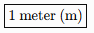
1 meter (m)
The meter is defined using the speed of light in a vacuum, making it one of the most precisely defined units in science.

Common Units of Length
# Source: AI Source: Provided by: [Data Path: Persons Table -> ID Column: 1, Name_En Column: Motasem Essam] -> From: [ChatGPT] on [7/17/2026]
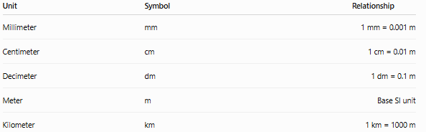
Unit | Symbol | Relationship
Millimeter | mm | 1 mm = 0.001 m
Centimeter | cm | 1 cm = 0.01 m
Decimeter | dm | 1 dm = 0.1 m
Meter | m | Base SI unit
Kilometer | km | 1 km = 1000 m

Common Imperial and USCS Units
# Source: AI Source: Provided by: [Data Path: Persons Table -> ID Column: 1, Name_En Column: Motasem Essam] -> From: [ChatGPT] on [7/17/2026]
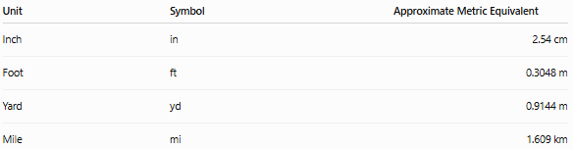
Unit | Symbol | Approximate Metric Equivalent
Inch | in | 2.54 cm
Foot | ft | 0.3048 m
Yard | yd | 0.9144 m
Mile | mi | 1.609 km

Measuring Instruments
# Source: AI Source: Provided by: [Data Path: Persons Table -> ID Column: 1, Name_En Column: Motasem Essam] -> From: [ChatGPT] on [7/17/2026]
Length can be measured using:
- Ruler
- Measuring tape
- Meter stick
- Vernier caliper
- Micrometer
- Laser distance meter
- Surveying instruments

Measurement Process
# Source: AI Source: Provided by: [Data Path: Persons Table -> ID Column: 1, Name_En Column: Motasem Essam] -> From: [ChatGPT] on [7/17/2026]
To measure length:
- Select an appropriate measuring instrument.
- Align the zero mark with one end of the object.
- Read the value at the opposite end.
- Record the measurement with the correct unit.

Examples
# Source: AI Source: Provided by: [Data Path: Persons Table -> ID Column: 1, Name_En Column: Motasem Essam] -> From: [ChatGPT] on [7/17/2026]
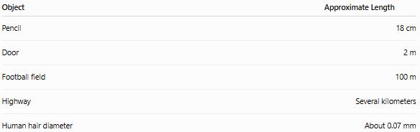
Object | Approximate Length
Pencil | 18 cm
Door | 2 m
Football field | 100 m
Highway | Several kilometers
Human hair diameter | About 0.07 mm

Unit Conversions
# Source: AI Source: Provided by: [Data Path: Persons Table -> ID Column: 1, Name_En Column: Motasem Essam] -> From: [ChatGPT] on [7/17/2026]
Common metric conversions:
- 1 km = 1000 m
- 1 m = 100 cm
- 1 cm = 10 mm
- 1 m = 1000 mm
Examples:
- 3 m = 300 cm
- 2.5 km = 2500 m
- 45 cm = 450 mm

Accuracy
# Source: AI Source: Provided by: [Data Path: Persons Table -> ID Column: 1, Name_En Column: Motasem Essam] -> From: [ChatGPT] on [7/17/2026]
Accurate length measurement depends on:
- Proper instrument selection.
- Correct alignment.
- Instrument calibration.
- Avoiding reading errors.

Precision
# Source: AI Source: Provided by: [Data Path: Persons Table -> ID Column: 1, Name_En Column: Motasem Essam] -> From: [ChatGPT] on [7/17/2026]
Precision refers to the consistency of repeated length measurements.
Example:
Repeated measurements:
- 25.02 cm
- 25.01 cm
- 25.03 cm
These measurements are highly precise.

Applications
# Source: AI Source: Provided by: [Data Path: Persons Table -> ID Column: 1, Name_En Column: Motasem Essam] -> From: [ChatGPT] on [7/17/2026]
Length measurement is essential in:
- Mathematics
- Engineering
- Construction
- Manufacturing
- Architecture
- Surveying
- Navigation
- Medicine
- Physics
- Cartography

Everyday Importance
# Source: AI Source: Provided by: [Data Path: Persons Table -> ID Column: 1, Name_En Column: Motasem Essam] -> From: [ChatGPT] on [7/17/2026]
Length measurement is used daily for:
- Measuring furniture.
- Buying fabric.
- Building houses.
- Driving distances.
- Measuring body height.
- Sports fields.
- Road signs.
- School activities.

Common Mistakes
# Source: AI Source: Provided by: [Data Path: Persons Table -> ID Column: 1, Name_En Column: Motasem Essam] -> From: [ChatGPT] on [7/17/2026]
- Using the wrong unit.
- Reading the scale from the wrong position (parallax error).
- Measuring with a damaged ruler or tape.
- Starting from a point other than zero.
- Recording the wrong unit.

Key Points
# Source: AI Source: Provided by: [Data Path: Persons Table -> ID Column: 1, Name_En Column: Motasem Essam] -> From: [ChatGPT] on [7/17/2026]
- Length measures the distance between two points.
- The SI base unit is the meter (m).
- Common metric units include millimeter, centimeter, meter, and kilometer.
- Length is measured using tools such as rulers, measuring tapes, calipers, and micrometers.
- Accurate measurements require proper technique and calibrated instruments.

Length vs. Distance
# Source: AI Source: Provided by: [Data Path: Persons Table -> ID Column: 1, Name_En Column: Motasem Essam] -> From: [ChatGPT] on [7/17/2026]
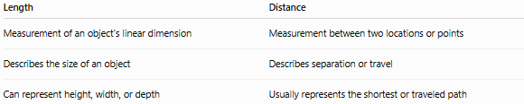
Length | Distance
Measurement of an object's linear dimension | Measurement between two locations or points
Describes the size of an object | Describes separation or travel
Can represent height, width, or depth | Usually represents the shortest or traveled path

Length vs. Width
# Source: AI Source: Provided by: [Data Path: Persons Table -> ID Column: 1, Name_En Column: Motasem Essam] -> From: [ChatGPT] on [7/17/2026]
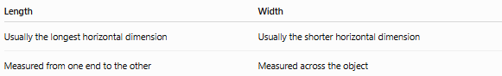
Length | Width
Usually the longest horizontal dimension | Usually the shorter horizontal dimension
Measured from one end to the other | Measured across the object

Length vs. Height
# Source: AI Source: Provided by: [Data Path: Persons Table -> ID Column: 1, Name_En Column: Motasem Essam] -> From: [ChatGPT] on [7/17/2026]
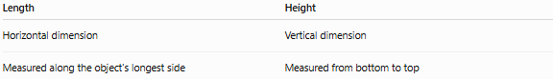
Length | Height
Horizontal dimension | Vertical dimension
Measured along the object's longest side | Measured from bottom to top

Conclusion
# Source: AI Source: Provided by: [Data Path: Persons Table -> ID Column: 1, Name_En Column: Motasem Essam] -> From: [ChatGPT] on [7/17/2026]
Length is the measurement of the linear distance between two points or the extent of an object in one dimension. As one of the seven SI base quantities, it uses the meter (m) as its standard unit. Length measurement is fundamental to science, engineering, manufacturing, construction, navigation, and everyday life, enabling accurate design, production, comparison, and communication of physical dimensions.

